9° Relatório de Controle



D=[1 166.67 6666]

D =

1.0e+003 *

0.0010 0.1667 6.6660

>> N=[-1 0]

N =

-1 0

Root Locus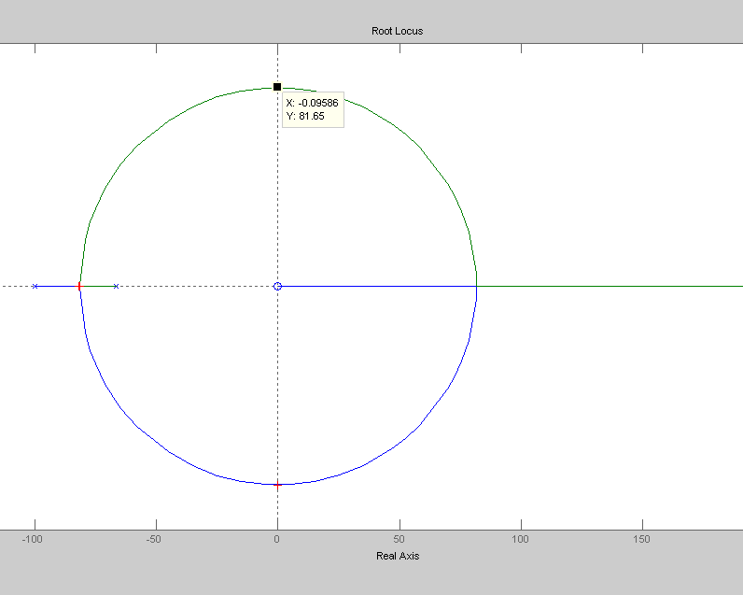

Para K= 0.1 OVS= ωn=81.65

|  |  |  |  |  |
| --- | --- | --- | --- | --- |
| K | OVS | ωn | ts | yss |
| 0.1 |  |  | 0.1 | 0.1 |

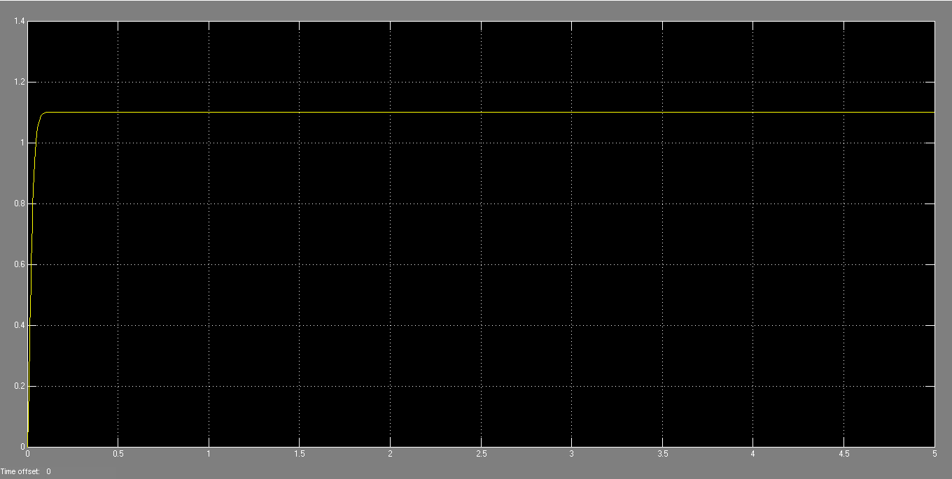

Para K=1.25, OVS=15% ωn=81.75

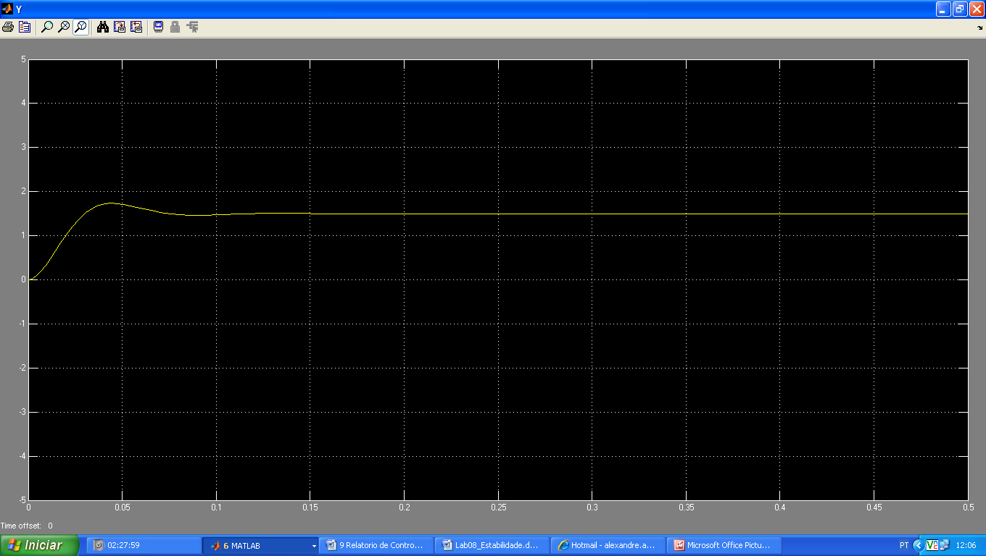

Para K=2.25 OVS=44% ωn=81.65

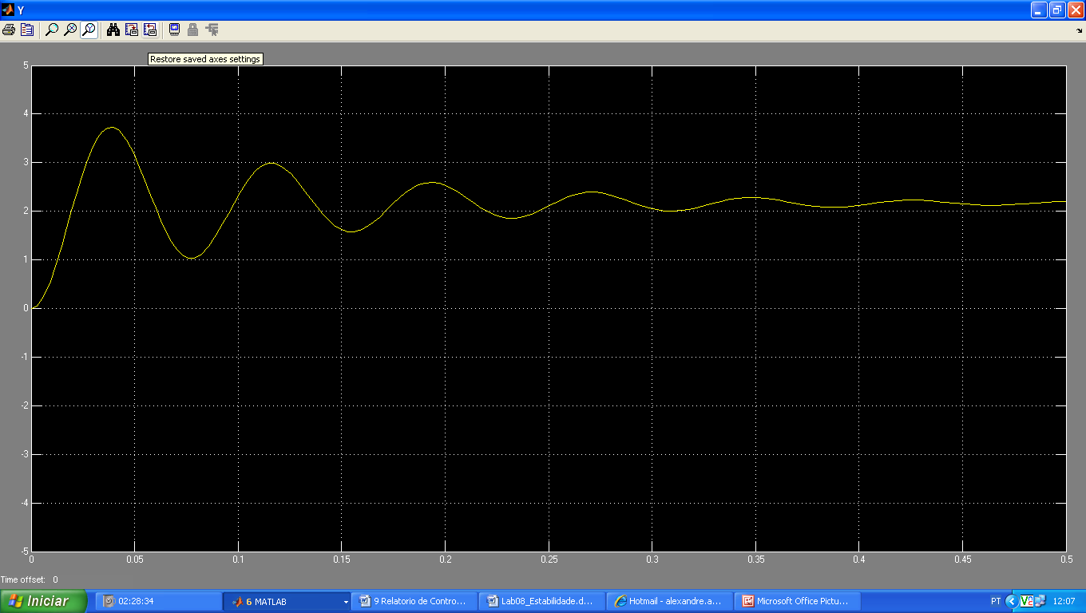

Para K=2.5 OVS=100% ωn=81.65

